[DRAFT] Penetration Testing Report

Prepared by: Sybrid (Pvt.) Ltd.

**Prepared for: XYZ, Ltd.**

V1.0 February | 10 | 2021

**[XYZ] – Company’s LOGO**

**Sybrid (Pvt.) Ltd.**

**Email: --- Web:** [**www.sybrid.com**](http://www.sybrid.com)

Table of Contents

Executive Summary 4

Test Scope 4

Results 4

Procedure 5

Recommendations 5

Testing Approach 5

Overview 5

Discovery & Reconnaissance 6

Validation & Exploitation 6

Internal Network Findings 7

Scope 7

Network Penetration Testing Results 7

Services by Host and by Port 7

Vulnerability Summary Table 7

Details 8

Observations 8

Impact 8

**Document Control**

|  |  |  |  |
| --- | --- | --- | --- |
| **Issue Control** | | | |
| **Document Reference** | n/a | **Project Number** | n/a |
| **Issue** | v1.0 | **Date** | 10 February 2021 |
| **Classification** | Confidential | **Author** |  |
| **Document Title** |  | | |
| **Approved by** |  | | |
| **Released by** |  | | |

|  |  |
| --- | --- |
| **Owner Details** | |
| **Name** |  |
| **Office/Region** |  |
| **Contact Number** |  |
| **E-mail** |  |

|  |  |  |  |
| --- | --- | --- | --- |
| **Revision History** | | | |
| **Issue** | **Date** | **Author** | **Comments** |
| 1.0 | 10 February 2021 | Ahmed Ajmal | n/a |
|  |  |  |  |

# Executive Summary

## Test Scope

## Results

|  |  |
| --- | --- |
| **Environment Tested** | **Testing Results** |
| **Internal Network** | Status [**Critical**, **Low**, **High**] |
| **Wireless Network** | Status [**Critical**, **Low**, **High**] |
| **Web Application** | Status [**Critical**, **Low**, **High**] |
| **Mobile Application** | Status [**Critical**, **Low**, **High**] |
| **Social Engineering Exercises** | Status [**Critical**, **Low**, **High**] |

## Procedure

## Recommendations

# Testing Approach

## Overview

*[Explanation of 4-Phases as per below figure]*



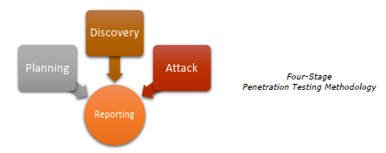

[Explanation of Discovery phase step-by-step]

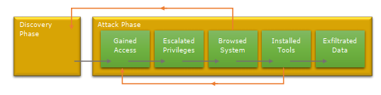

## Discovery & Reconnaissance

## Validation & Exploitation

# Internal Network Findings

## Scope

|  |
| --- |
| **Target IP Addresses** |
| 192.x.x.x |
| 100.x.x.x |
| 172.x.x.x |

## Network Penetration Testing Results

|  |  |
| --- | --- |
| **Result Classification** | |
| **Vulnerabilities Found** | Status [**YES**, **NO**] |
| **Exploited – Denial of Service (DoS)** | Status [**YES**, **NO**] |
| **Exploited – Elevation of Privileges (EoP)** | Status [**YES**, **NO**] |
| **Exploited – Remote Code Execution (RCE)** | Status [**YES**, **NO**] |
| **Exploit Persistent Achieved** | Status [**YES**, **NO**] |
| **Sensitive Data Exfiltrated** | Status [**YES**, **NO**] |
| **Overall Risk** | Status [**High**, **Low**] |

## Services by Host and by Port

|  |  |  |  |  |
| --- | --- | --- | --- | --- |
| **IP Addresses** | **TCP/UDP** | **Port** | **Service** | **Version** |
| **192.x.x.x** | Tcp | 22 | ssh | OpenSSH 7.x (protocol 2.x) |

## Vulnerability Summary Table

|  |  |  |  |
| --- | --- | --- | --- |
| **#** | **Vulnerability Summary** | **Risk Level** | **Recommendations** |
| 1 | [name & security control issue] | Status [**Critical**, **High**, **Medium**, **Low**] | [solutions] |

### Details

|  |  |
| --- | --- |
| 1. **[Vulnerability 1 Name]** | |
| **Risk** | Status [**Critical**, **High**, **Medium**, **Low**] |
| **Location** | **192.x.x.x: Port** |
| **Description** | |

### Observations

*[Process]*

*[Images]*

### Impact

|  |  |
| --- | --- |
| **CVSS Score** | Scale [1-10] |
| **Confidentiality** |  |
| **Integrity** |  |
| **Availability** |  |
| **Access Complexity** |  |
| **Recommendations** |  |
| **References** |  |